Q1.

1. Greatest among four number

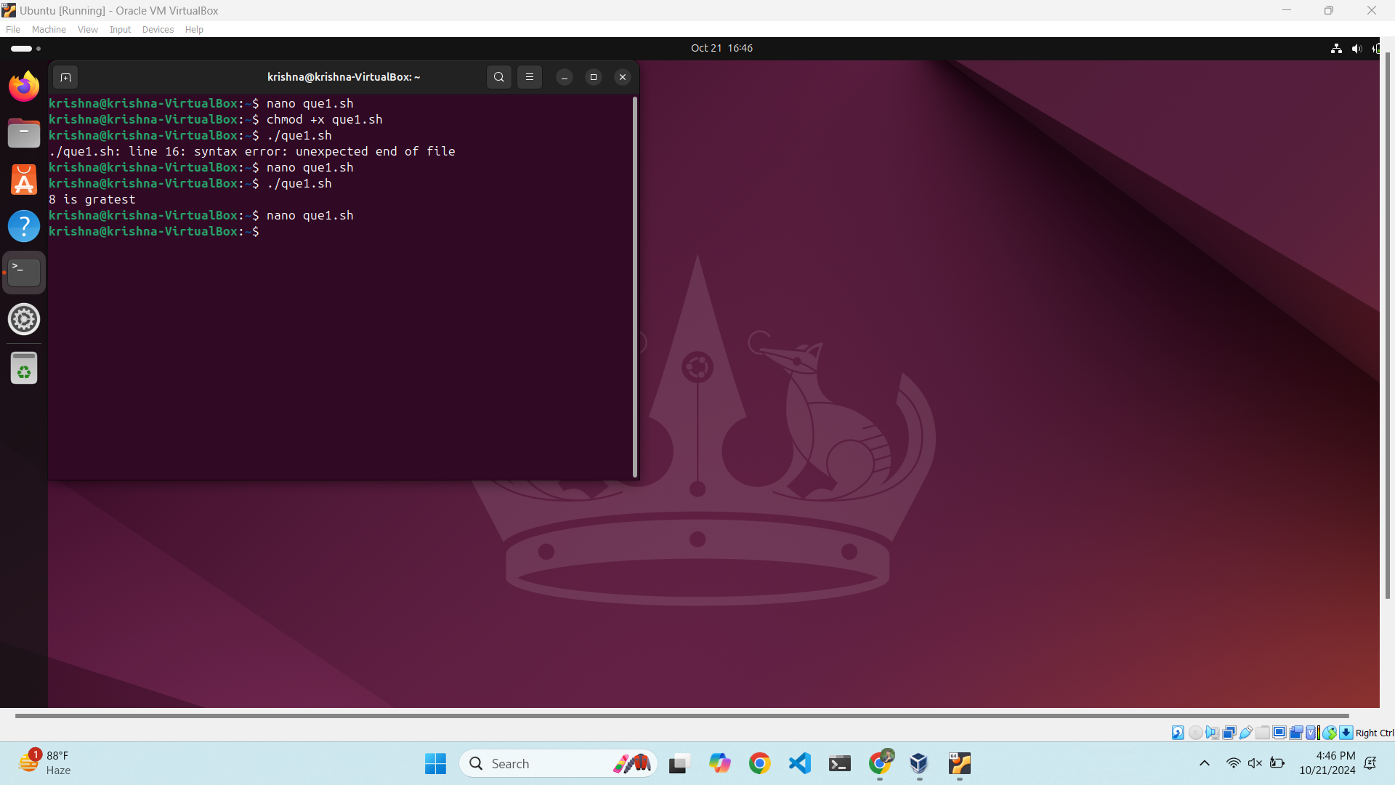

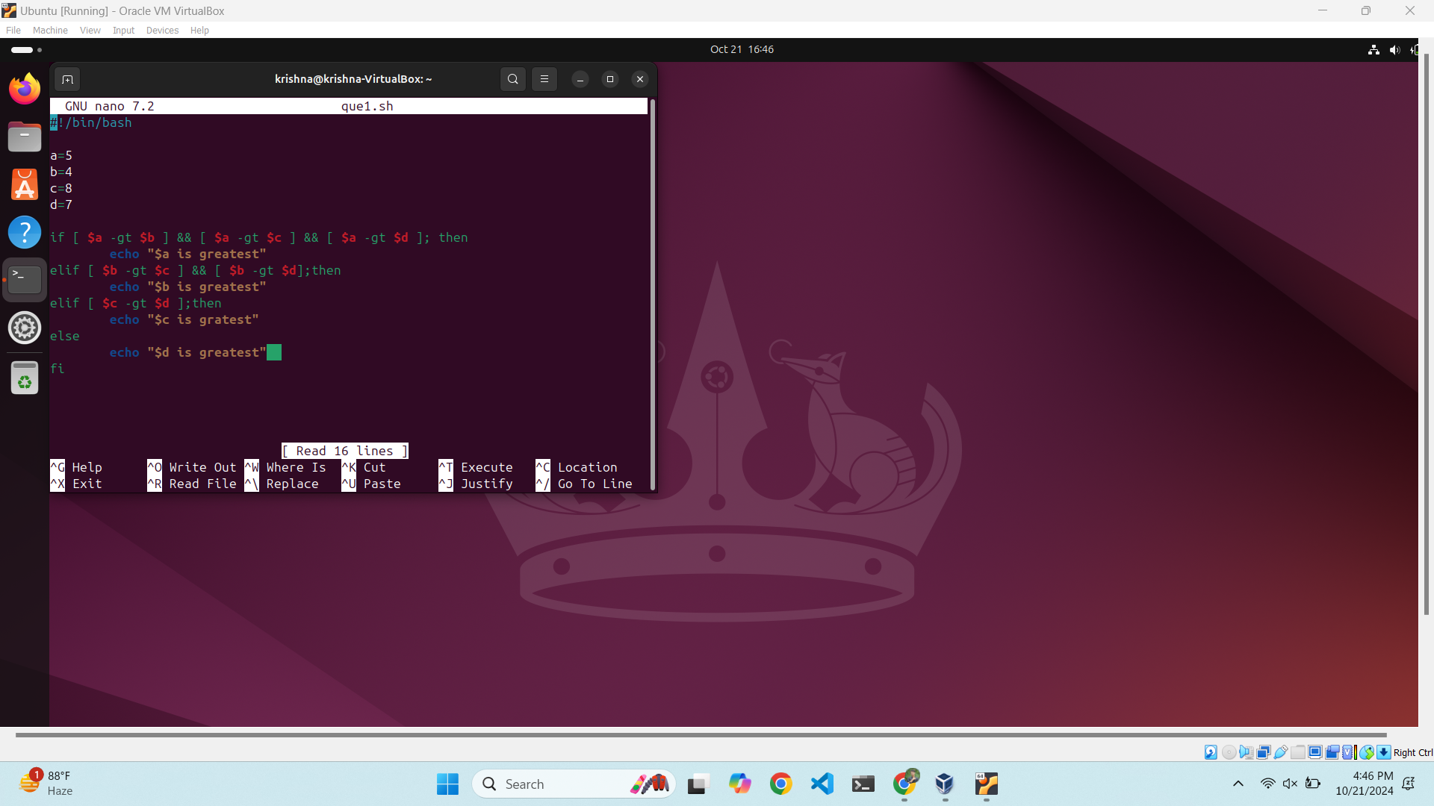

Code-

#!/bin/bash

a=5

b=4

c=8

d=7

If [ $a -gt $b ] && [ $a -gt $c] && [ $a -gt $d ]; then

echo “ $a is greatest ”

eiIf [ $b -gt $c ] && [ $b -gt $d]; then

echo “ $a is greatest ”

eiIf [ $c -gt $d ]; then

echo “ $c is greatest ”

else

echo “ $d is greatest ”

fi

1. Product of four number

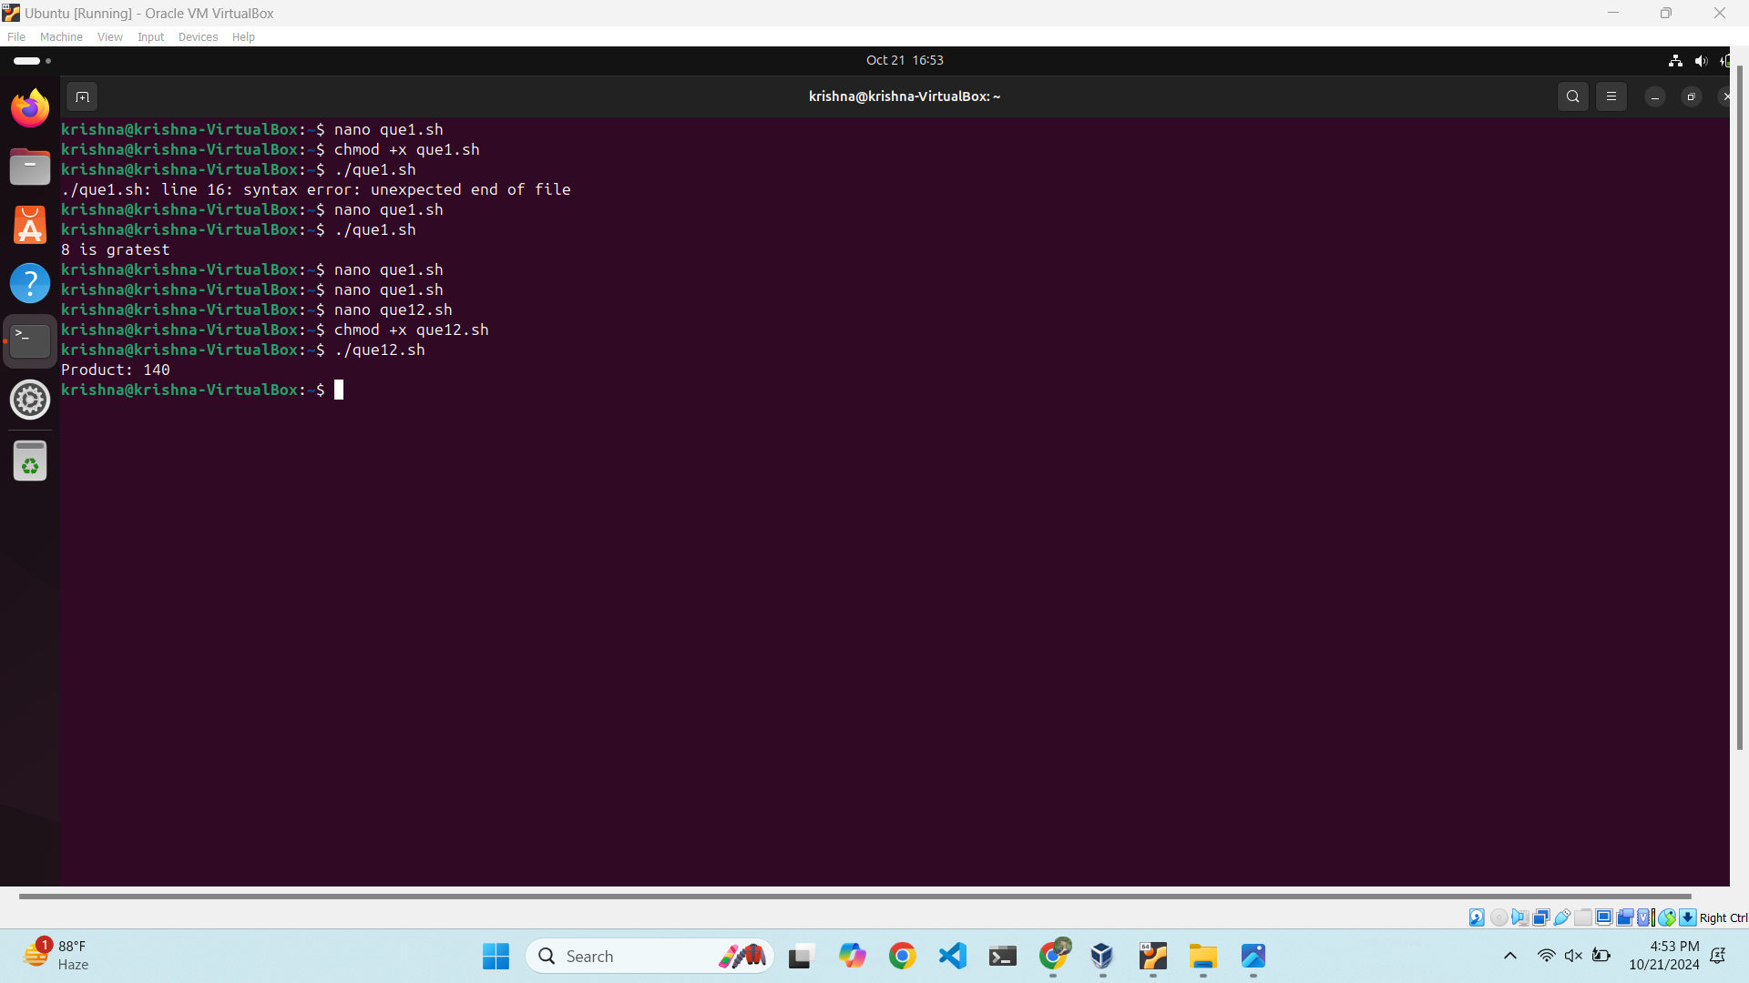

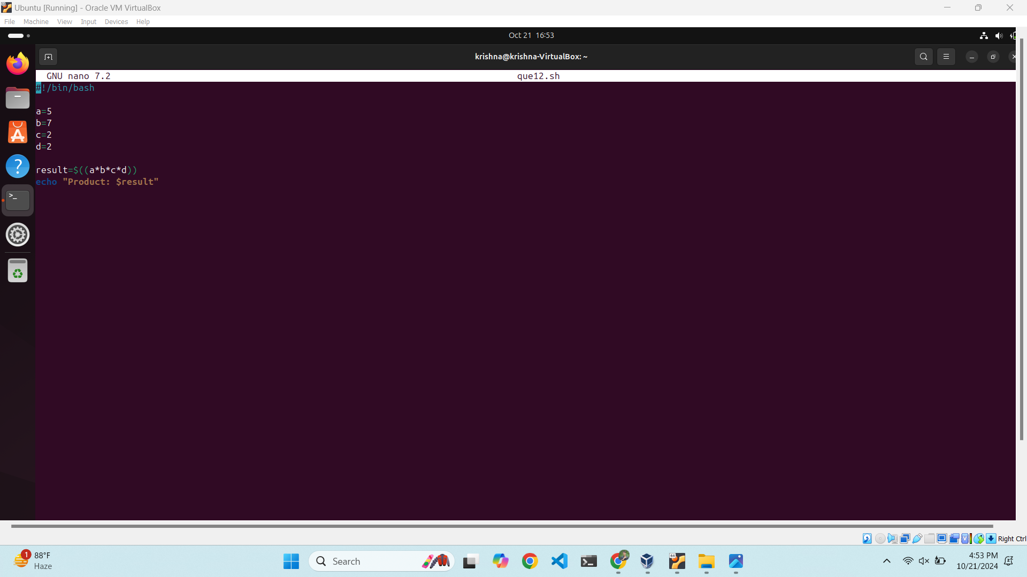

Code-

#!/bin/bash

a=5

b=7

c=2

d=2

result=$((a*b*c*d))

echo “Product: $result”

1. Average of four number

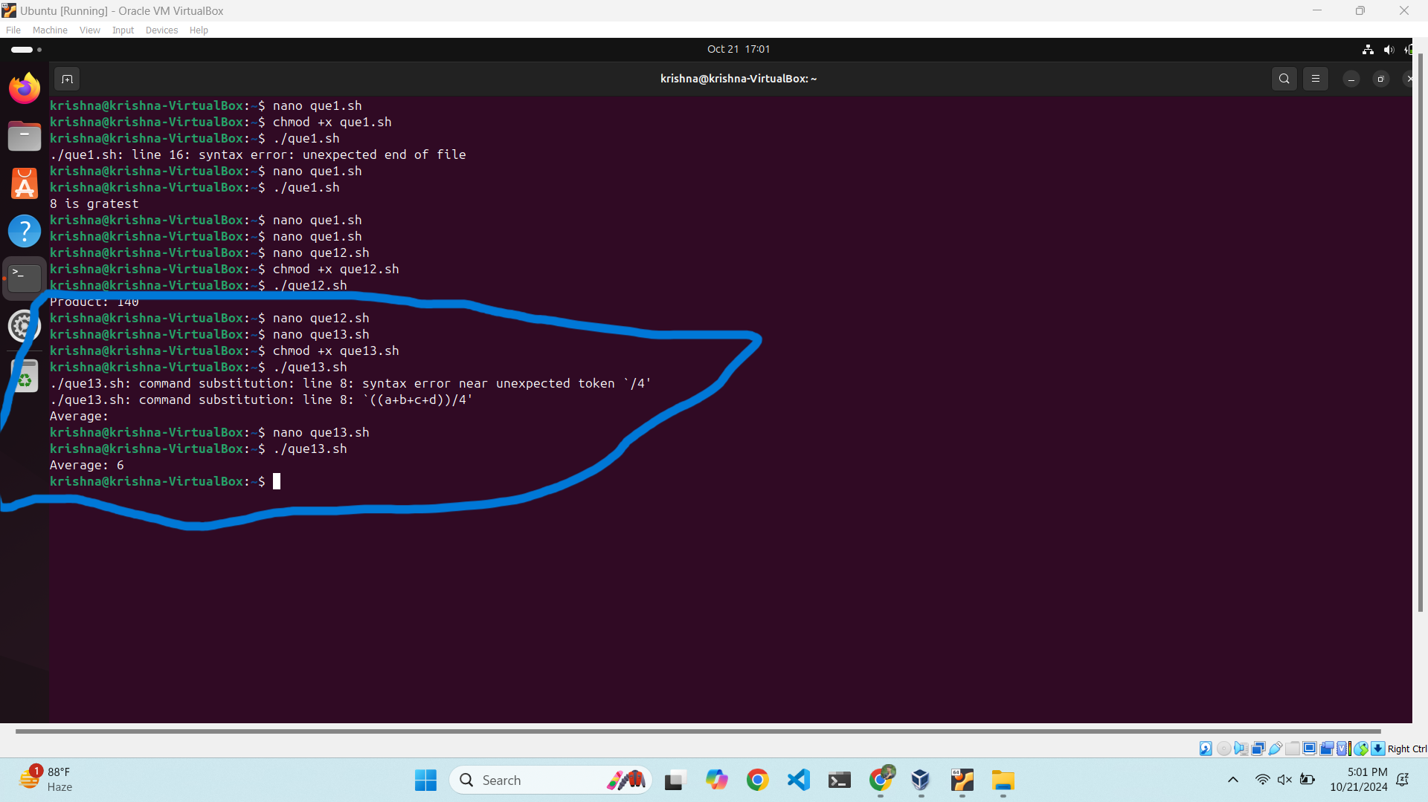

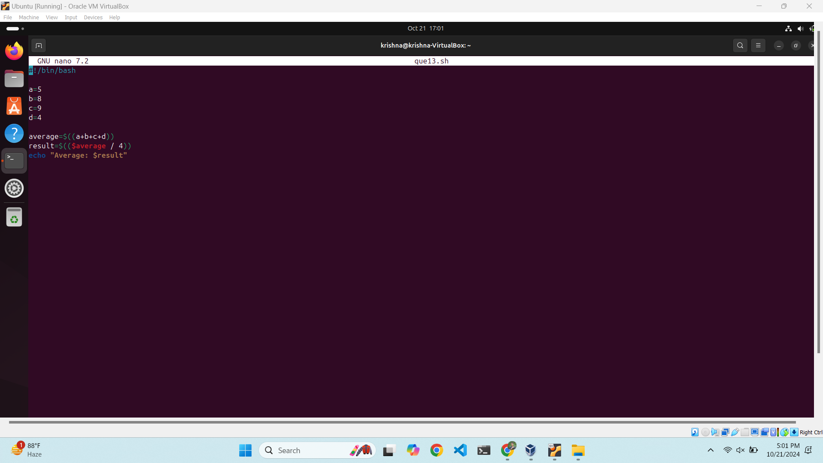

Code-

#!/bin/bash

a=5

b=8

c=9

d=4

average=$((a+b+c+d))

result=$(($average / 4))

echo “Average: $result”

Q2.

Create new directory

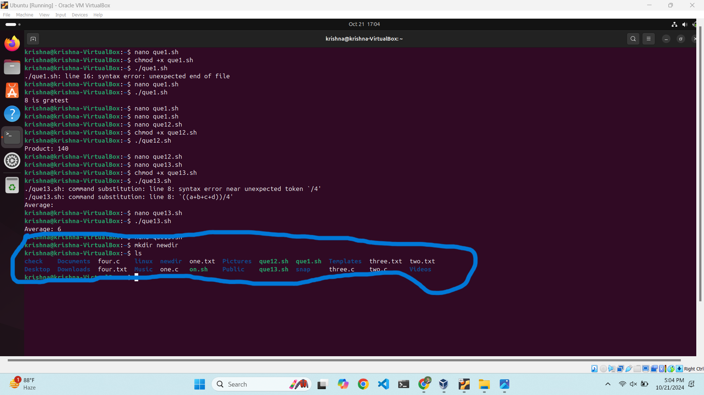

Cloud

Create an IAM user

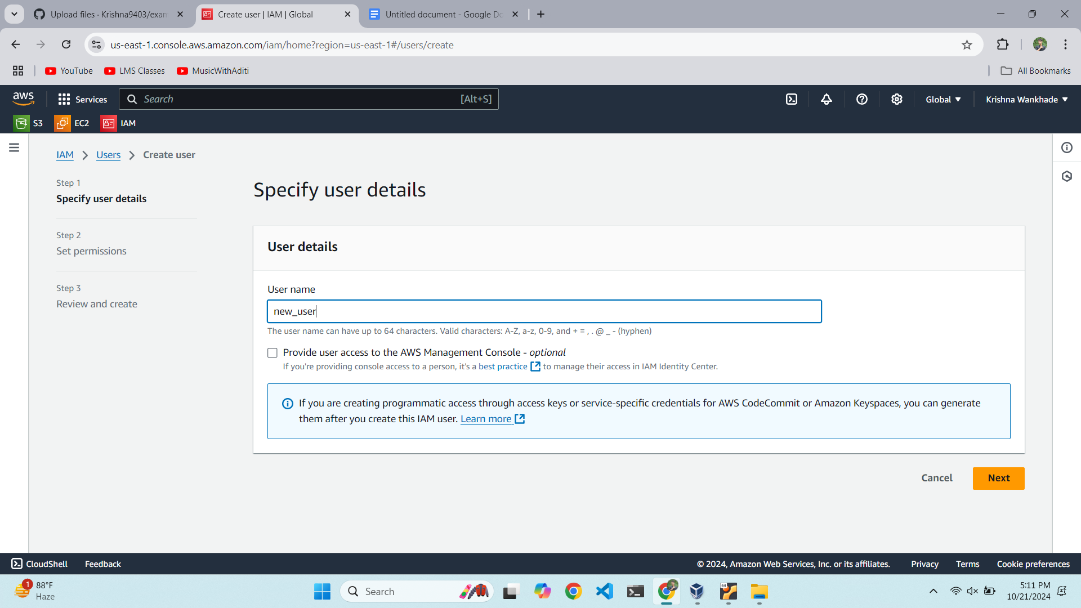

Giving permission

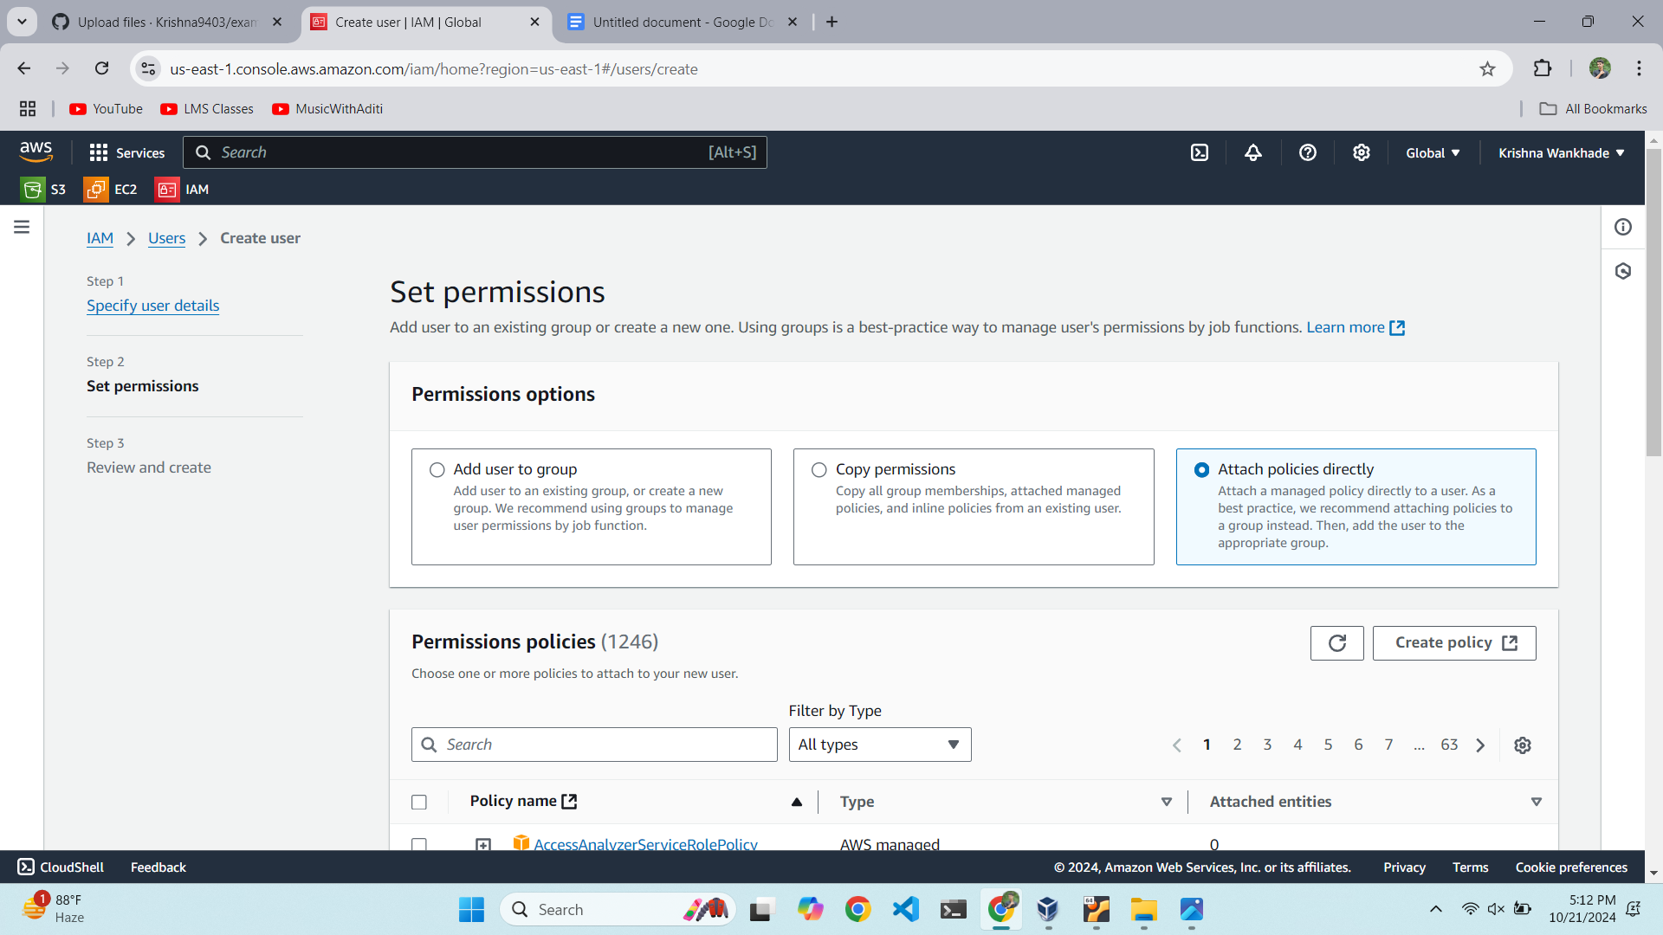

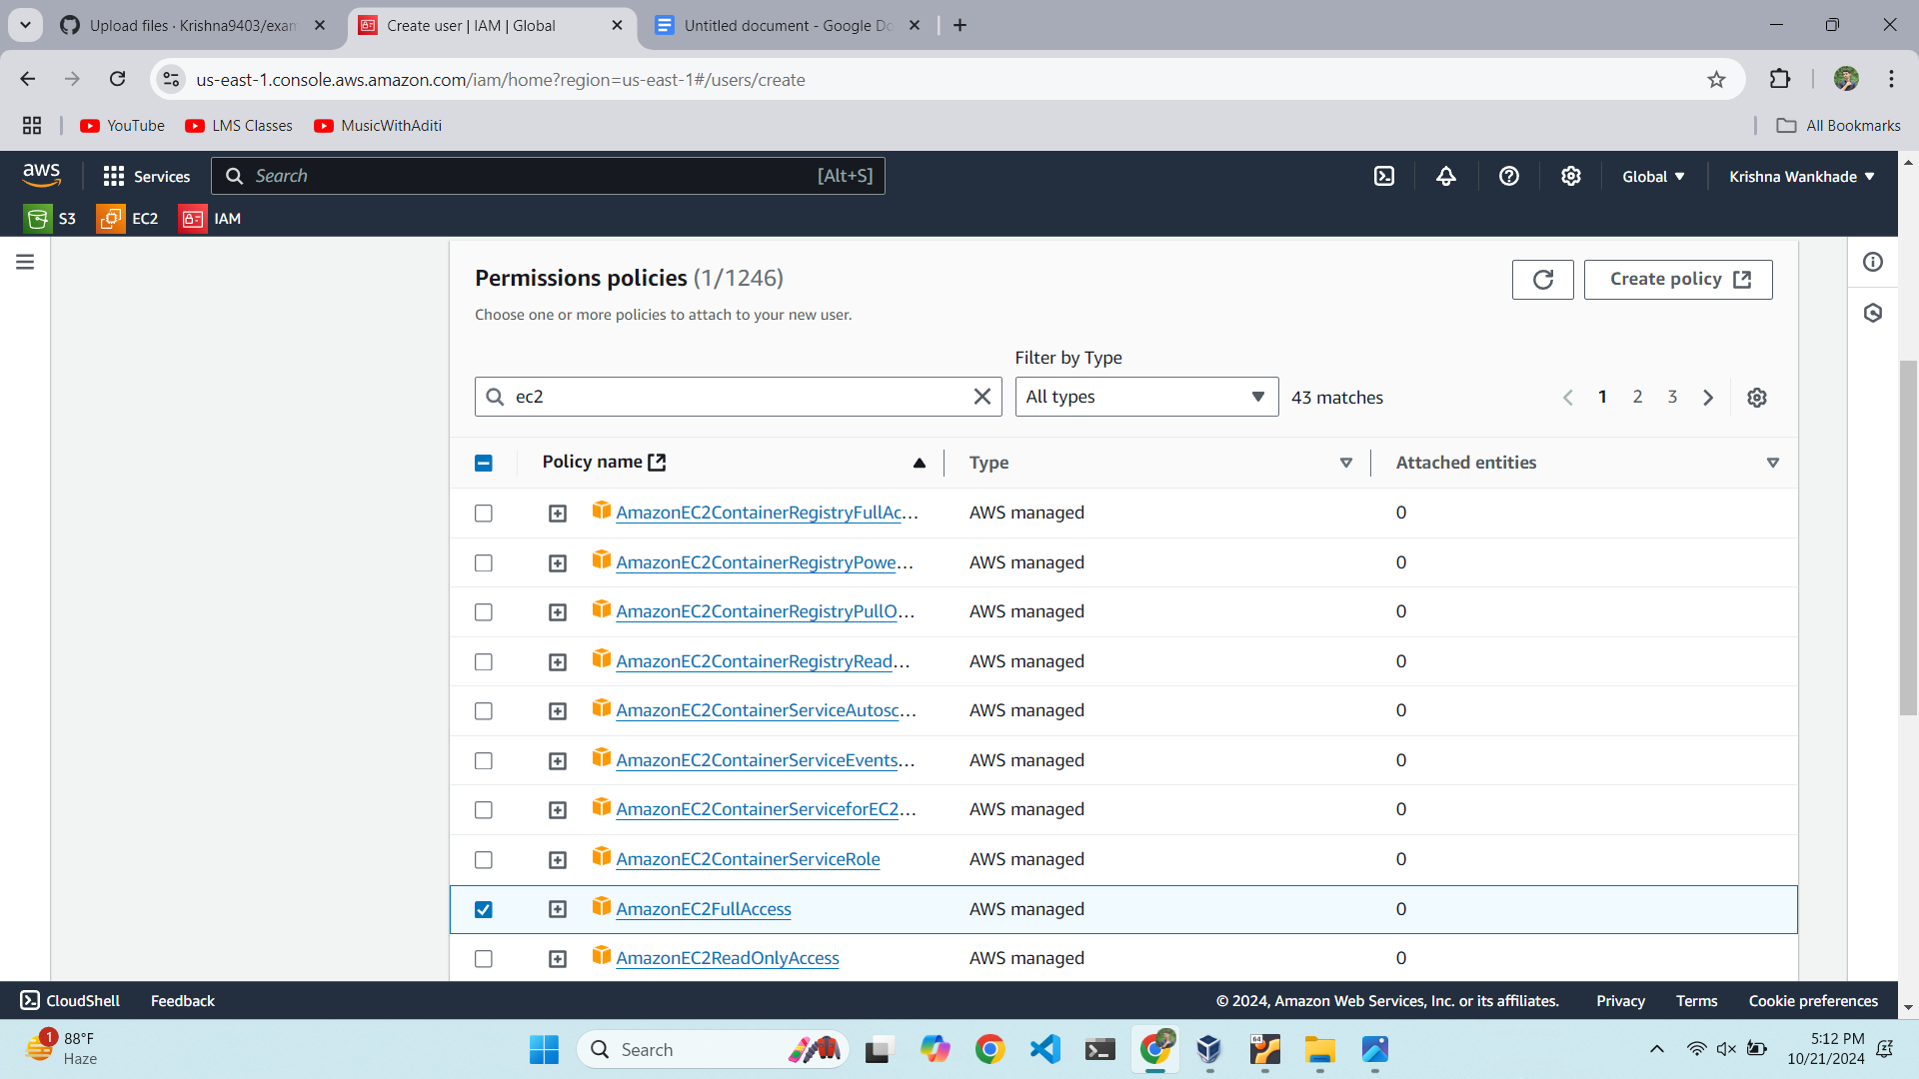

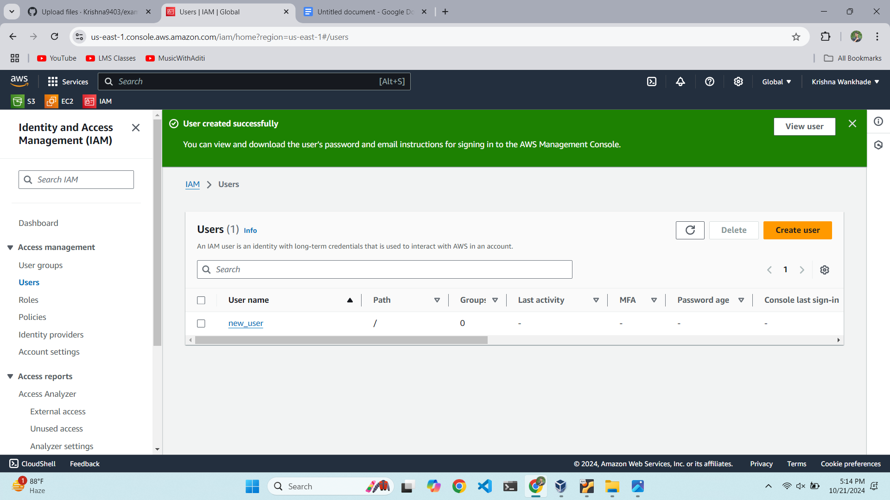

Enabling Console acces

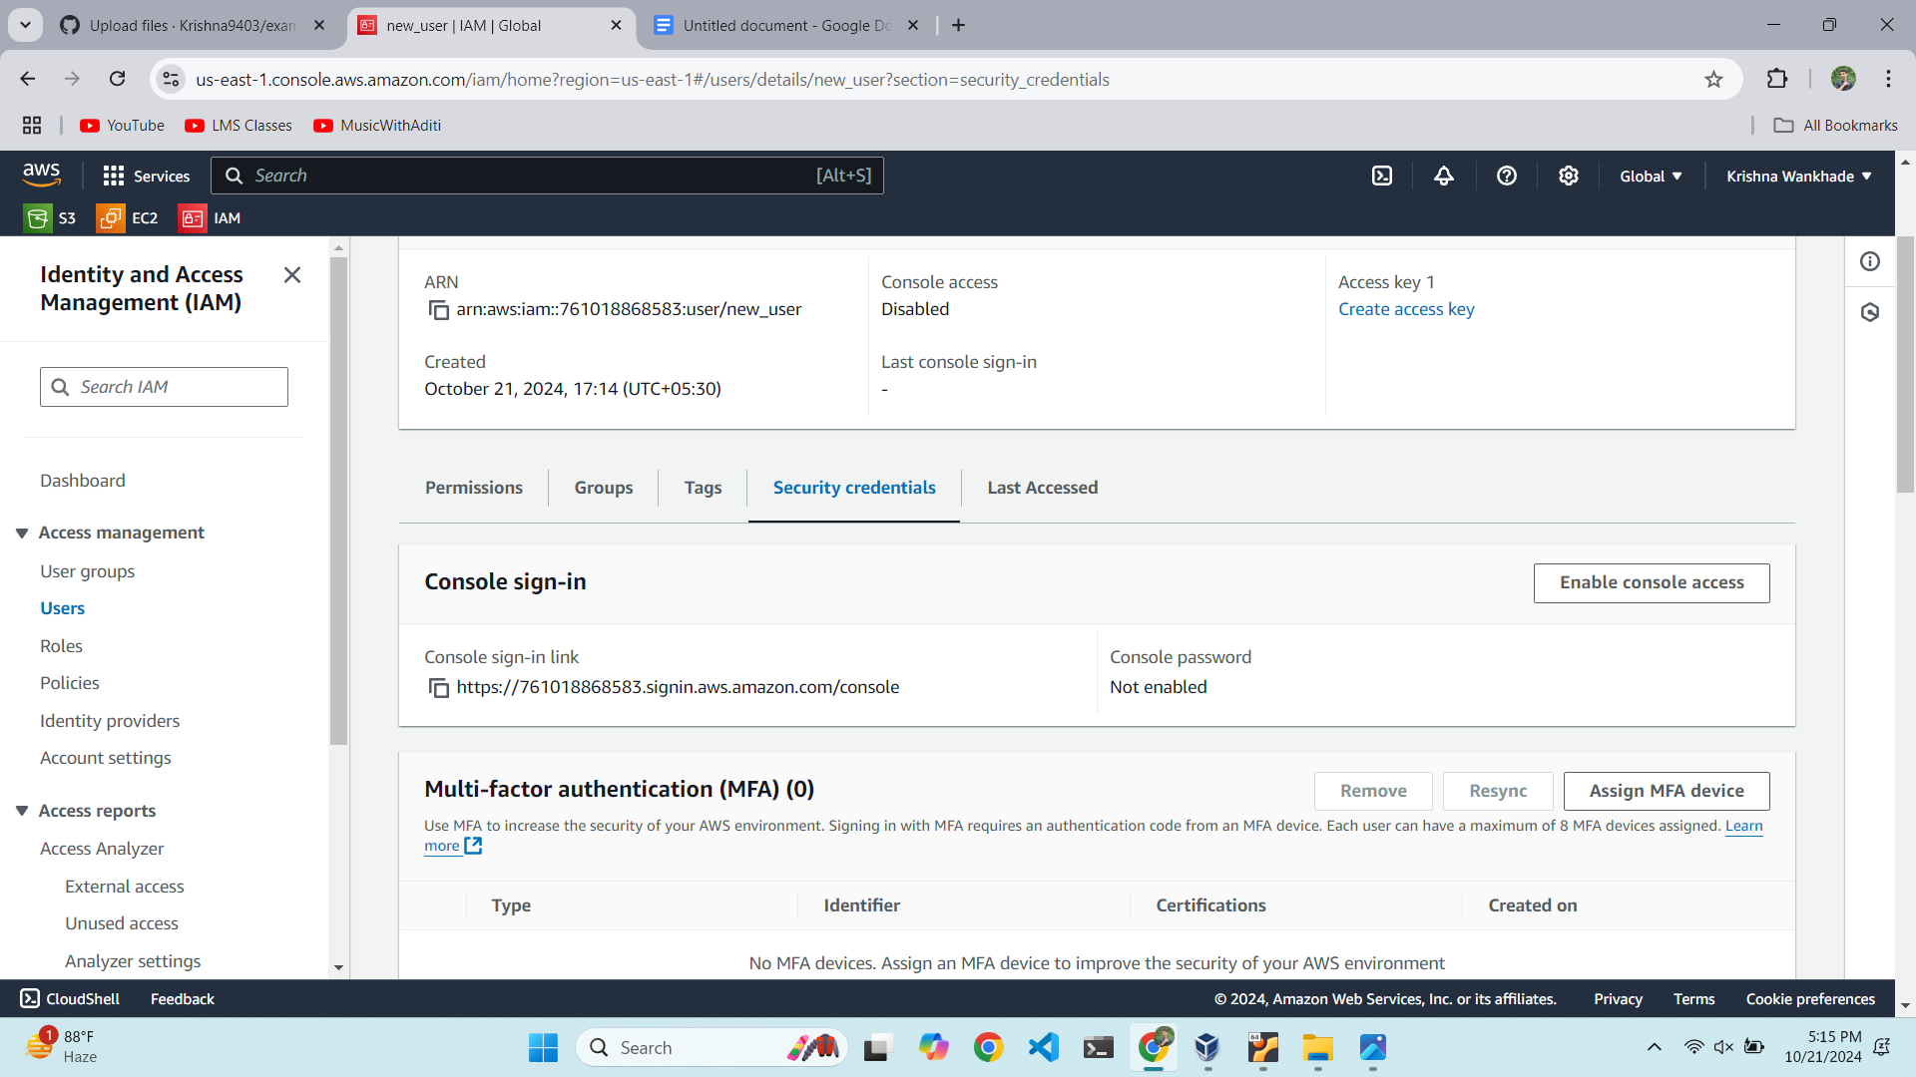

Set to auto generate password

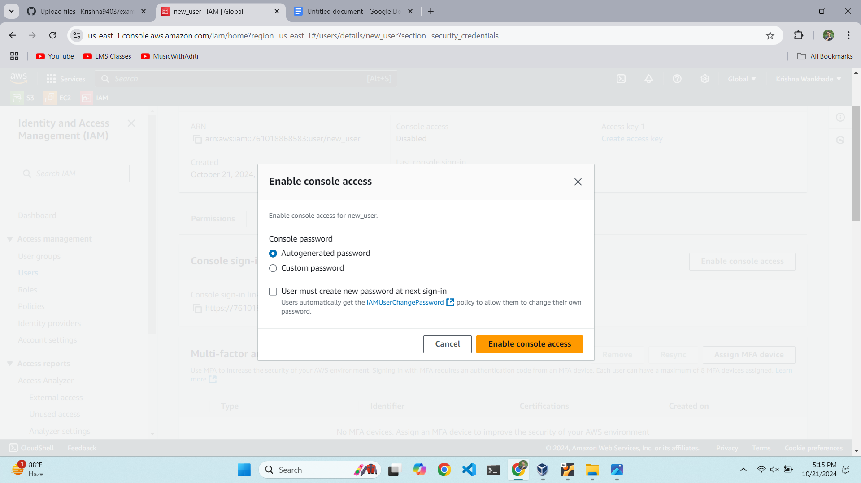

Logging in with new IMA username and password

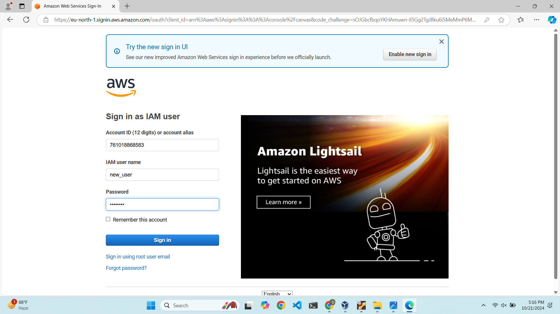

Creating new instance

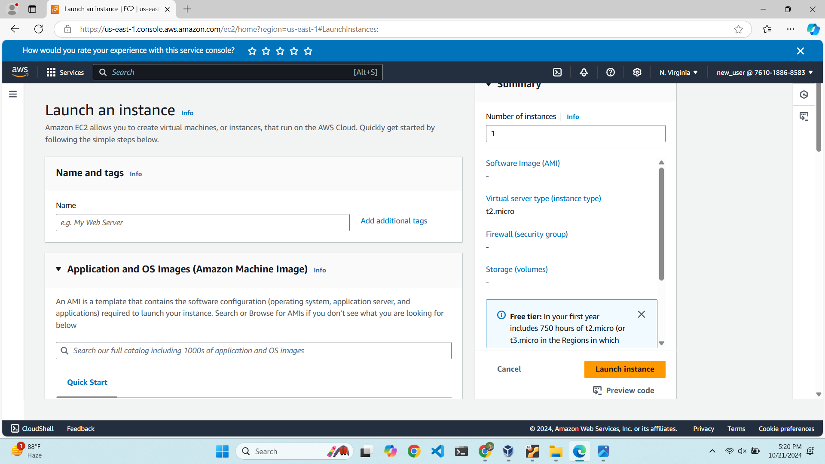

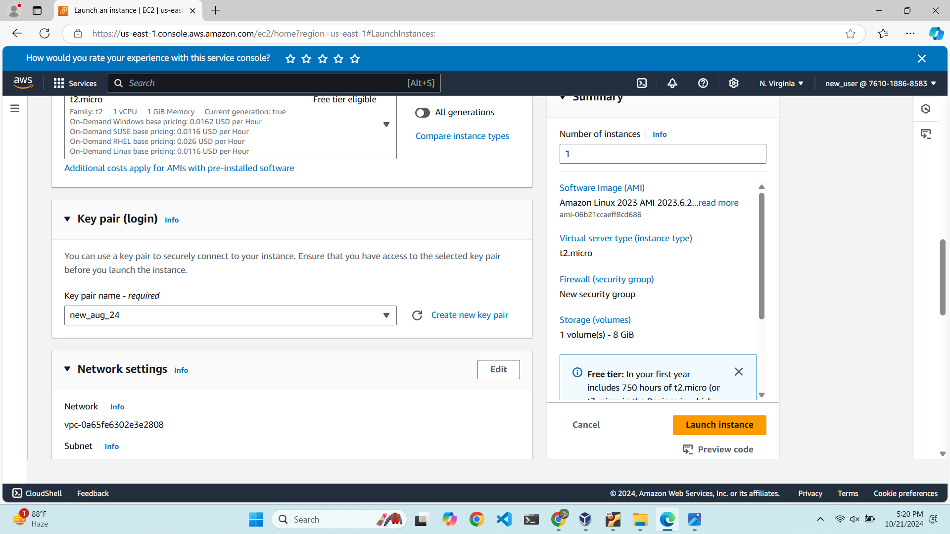

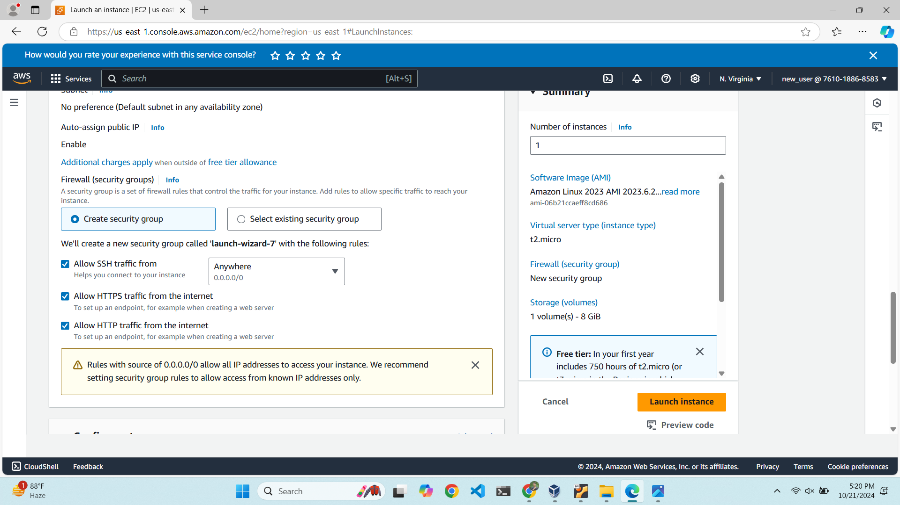

New instance with public IPv4 address

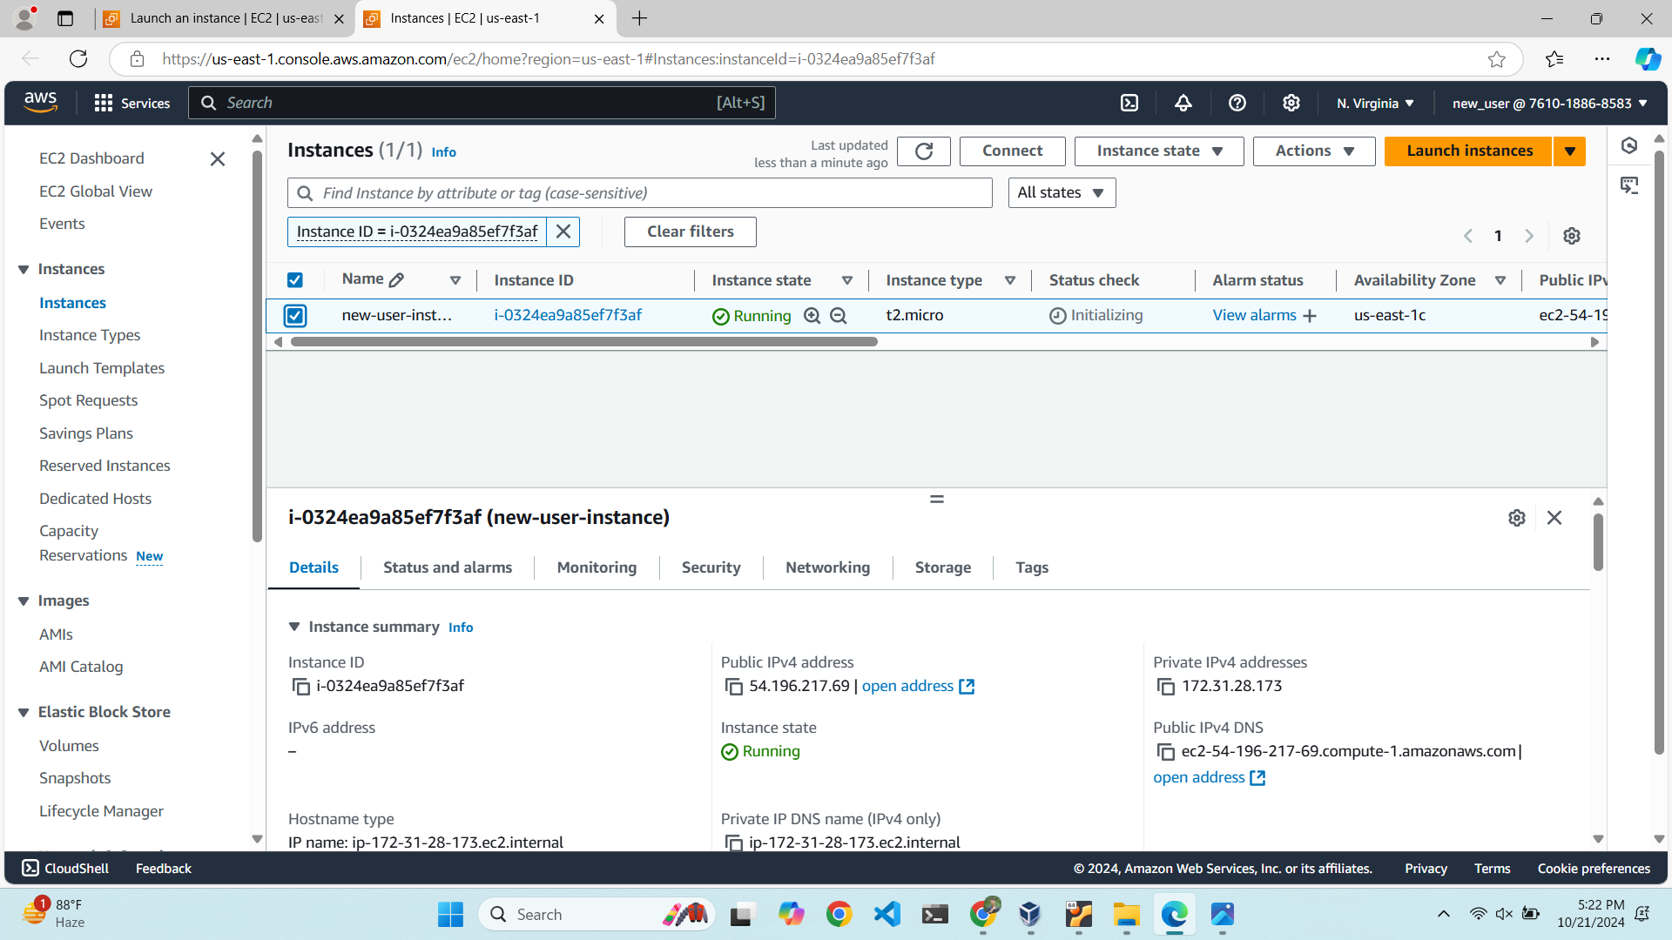

Create html file

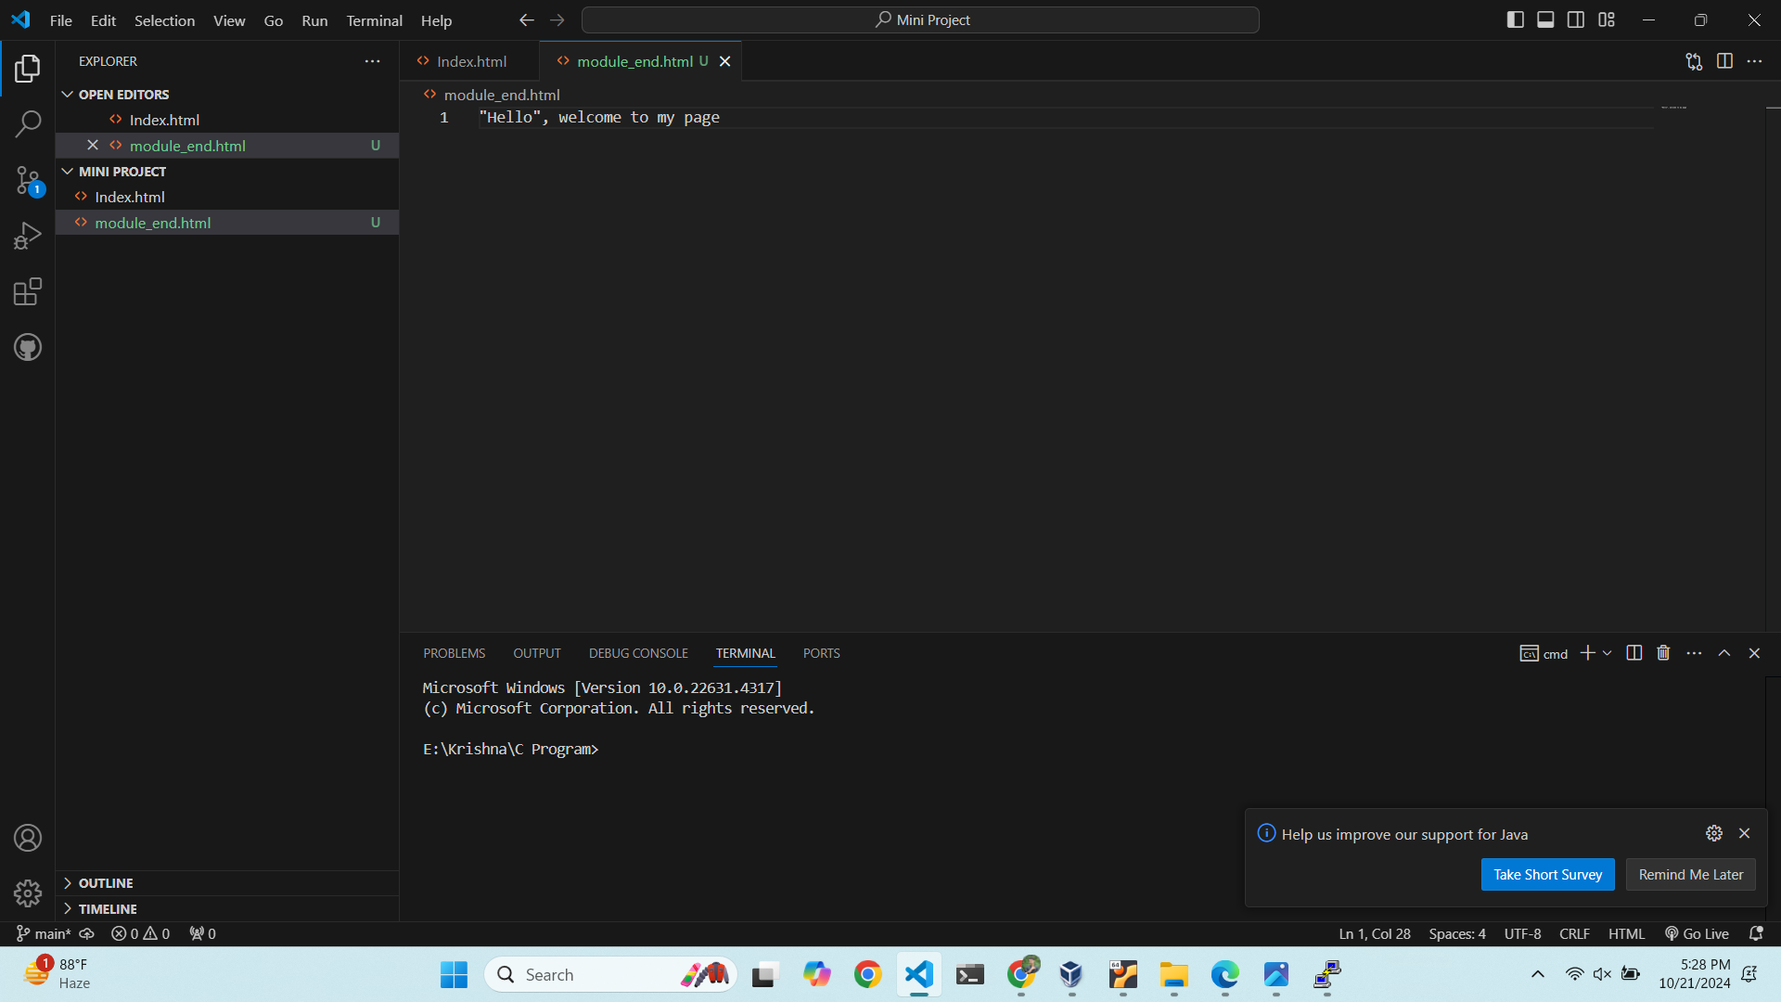

Creating s3 bucket

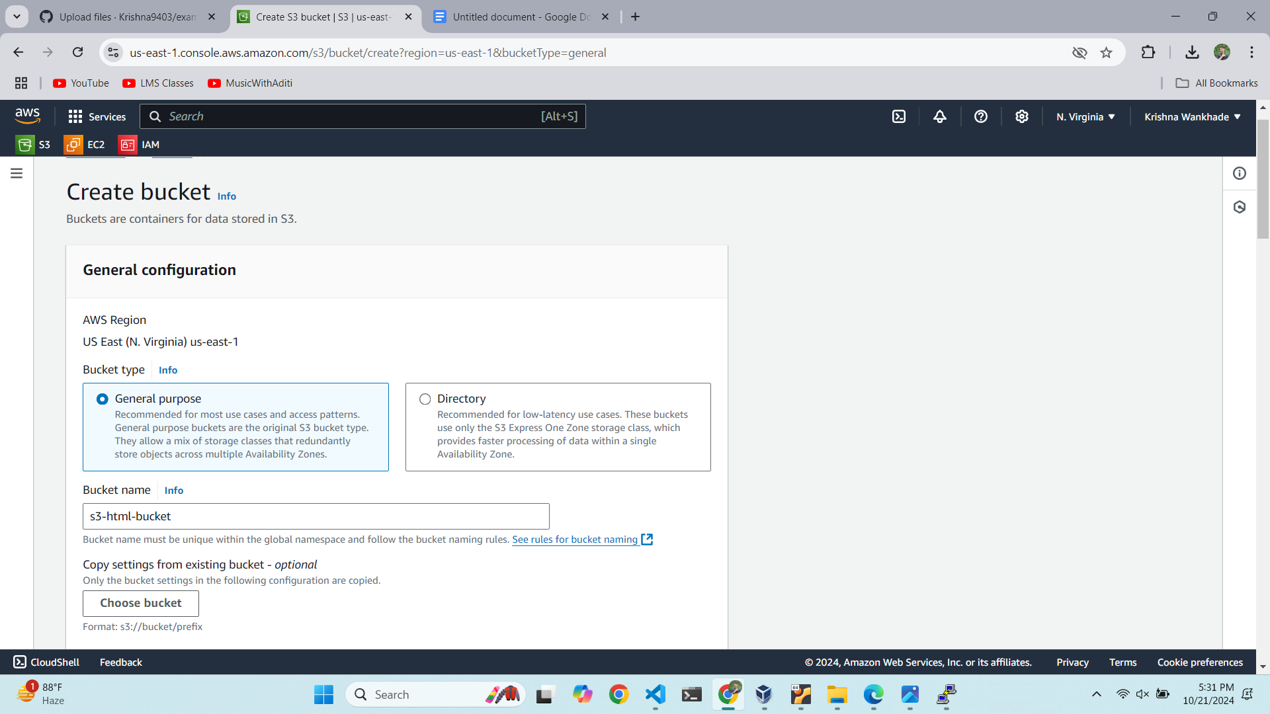

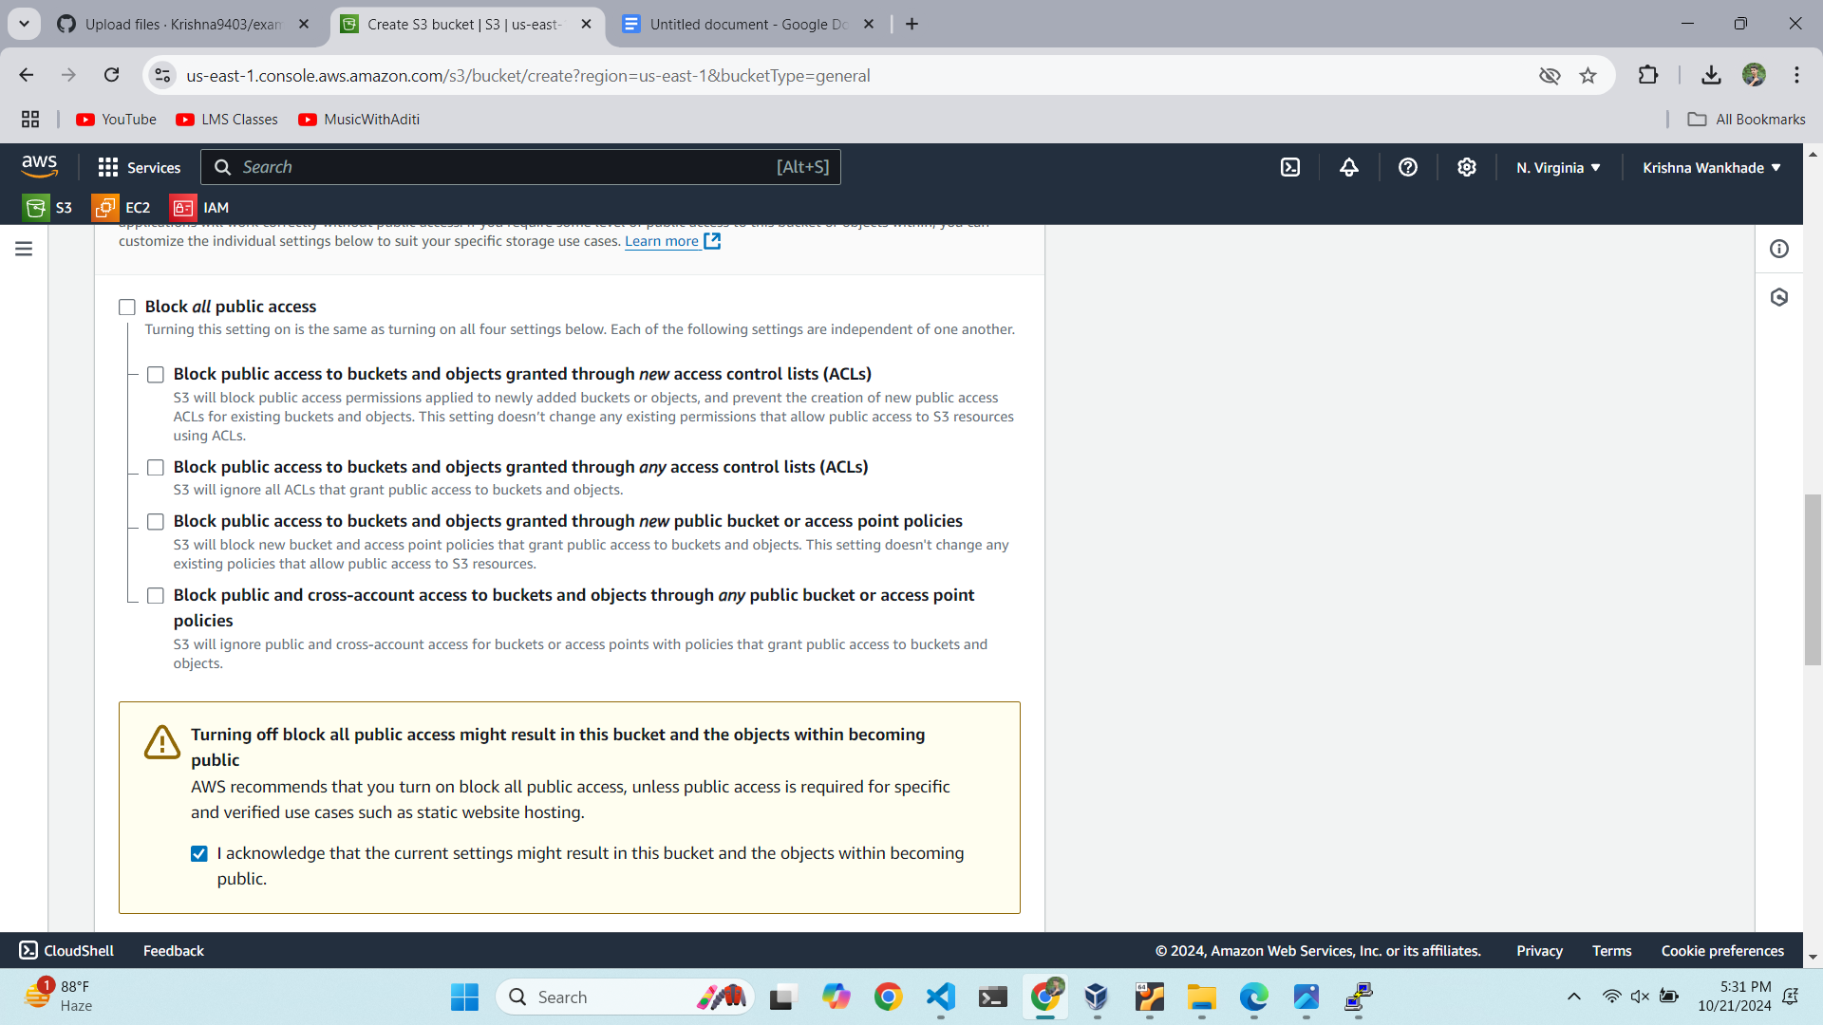

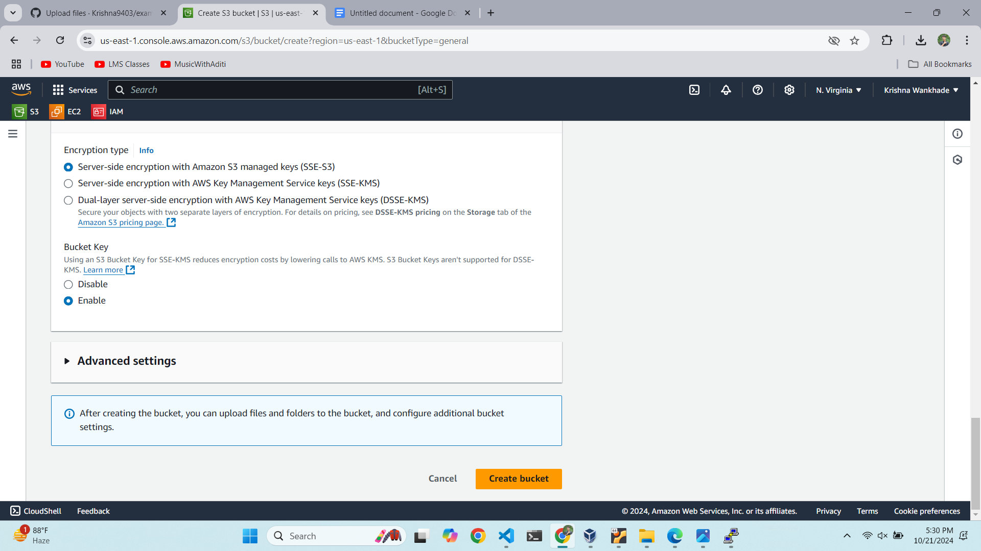

Bucket created

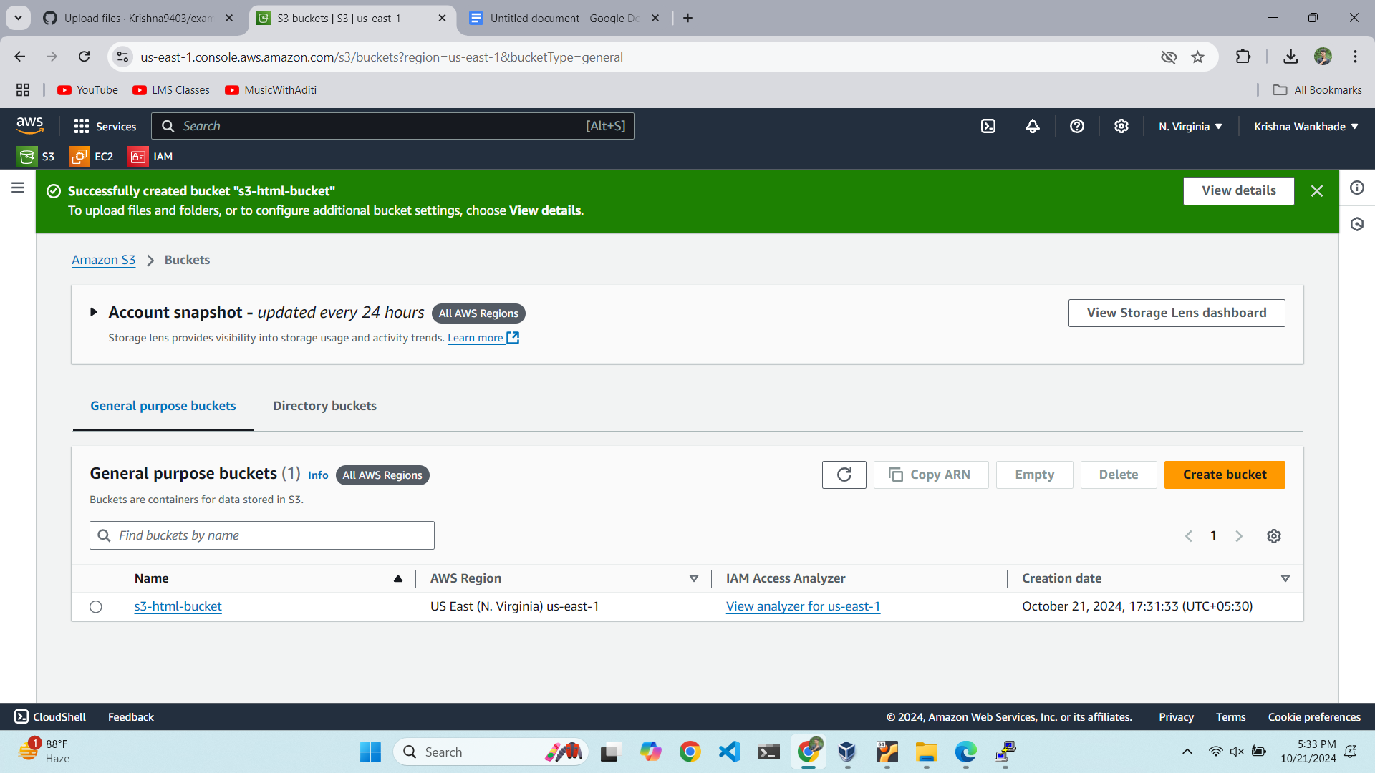

Adding html file

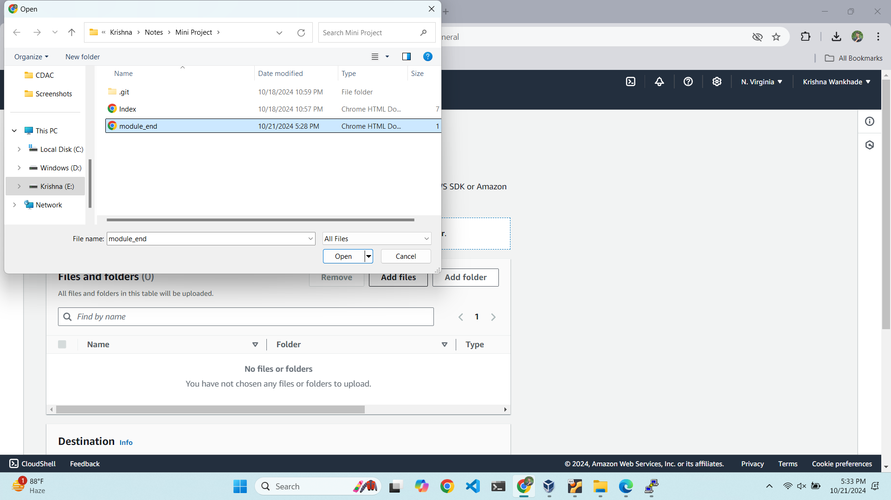

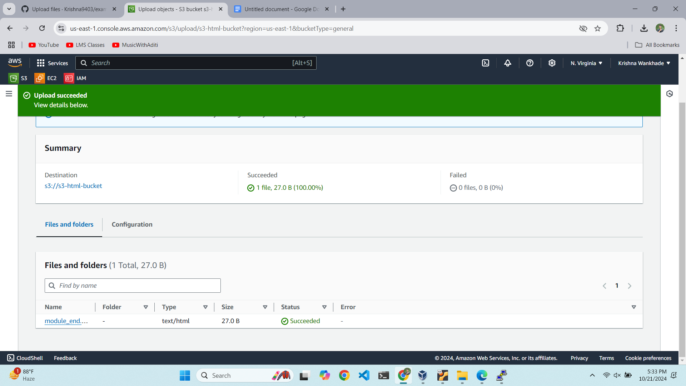

Giving permission to read and write

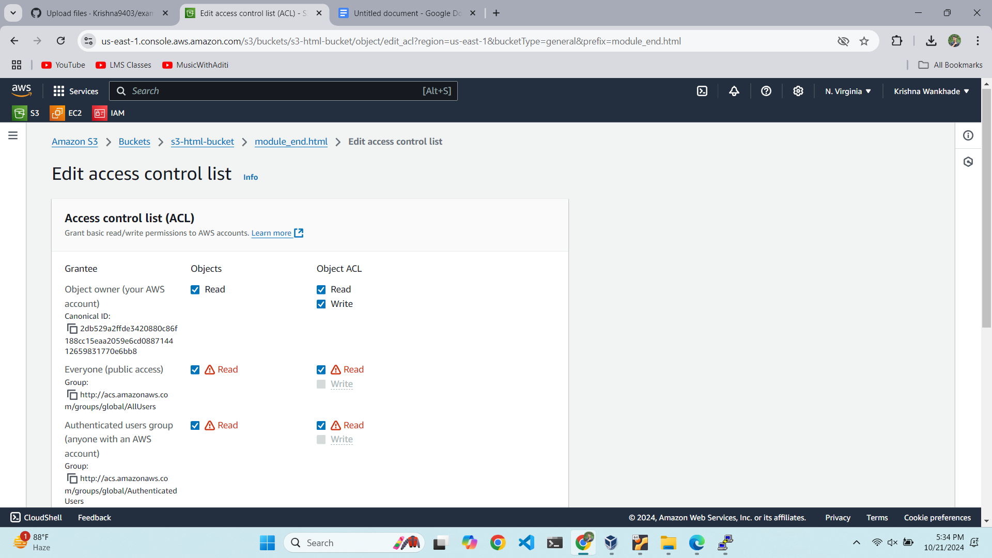

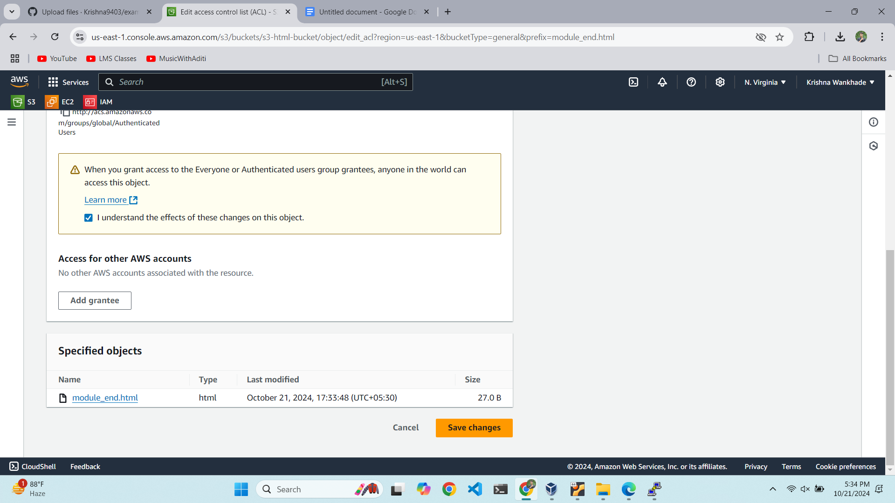

Ensuring bucket is configured to host static website content

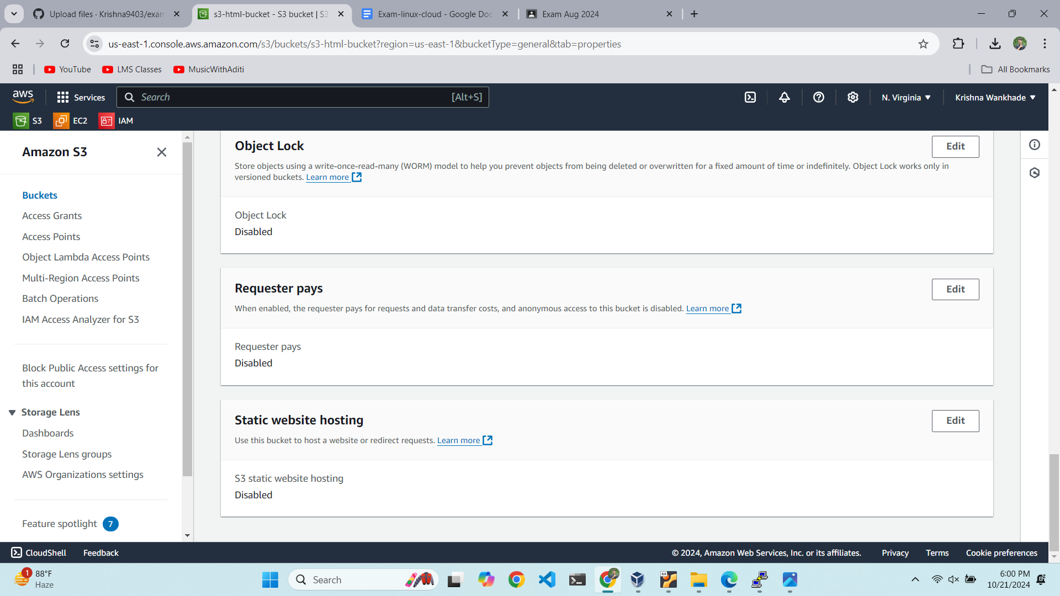

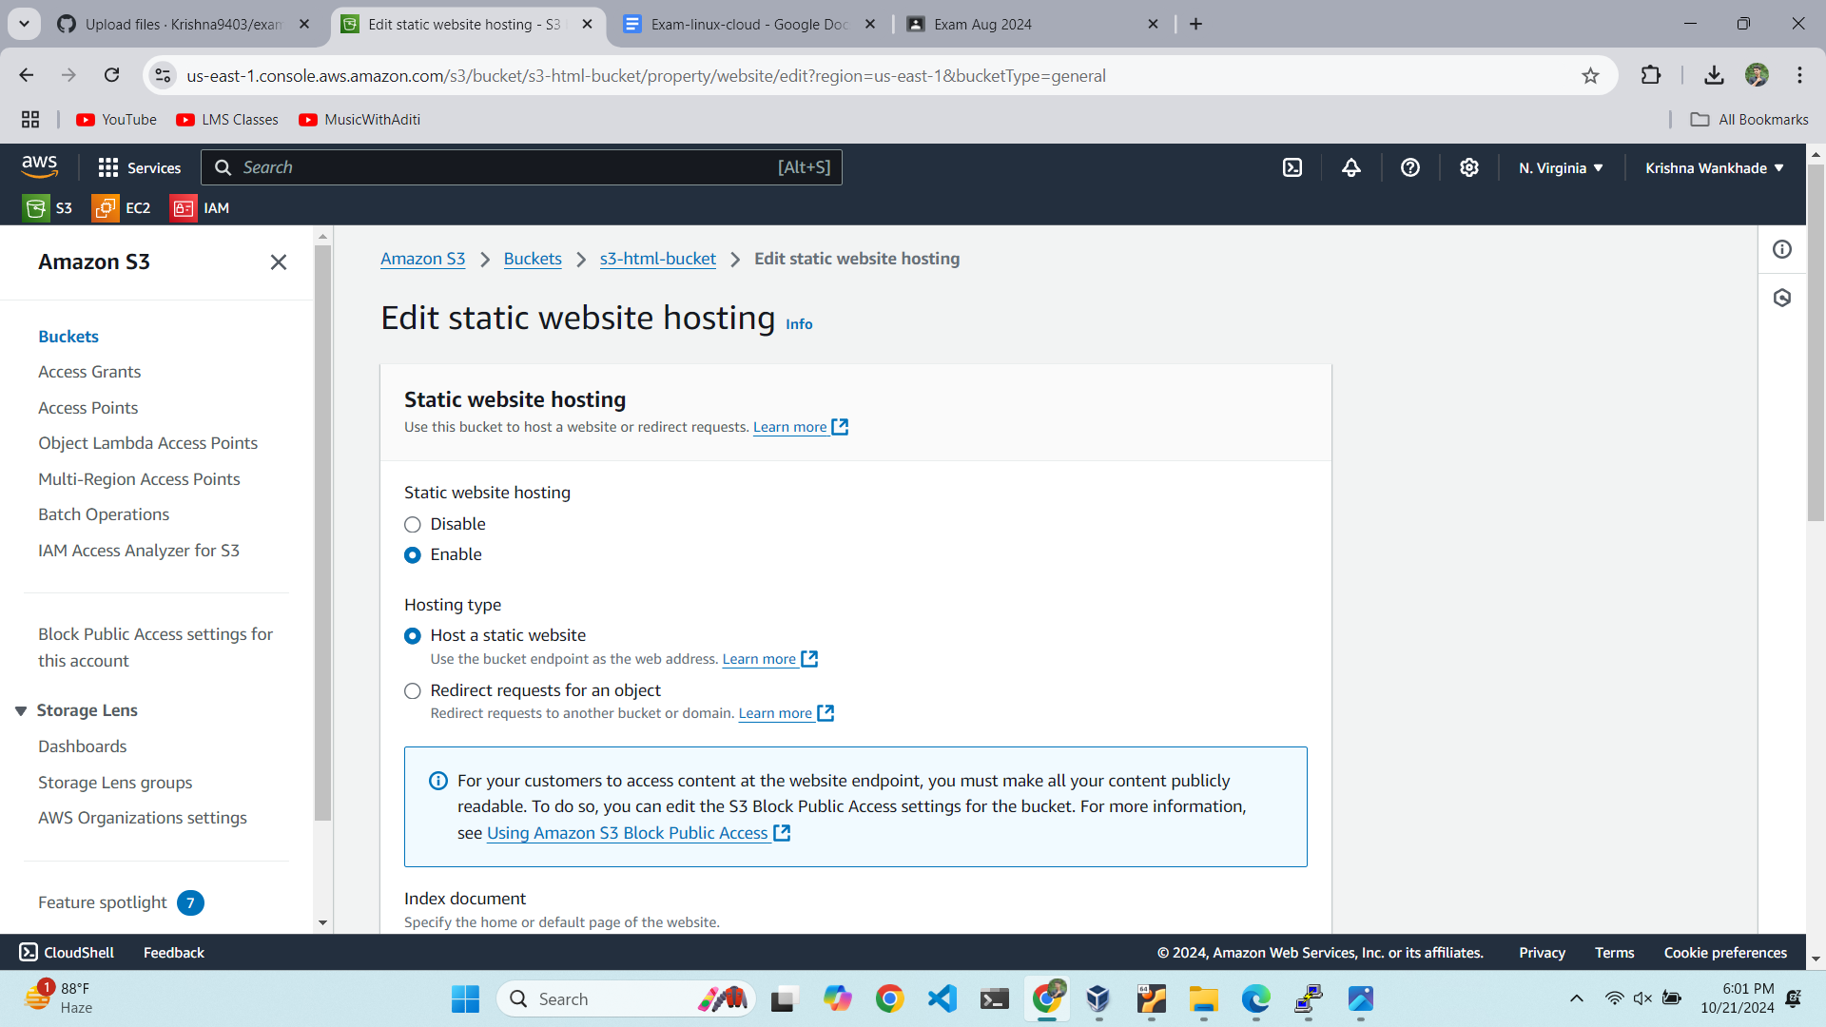

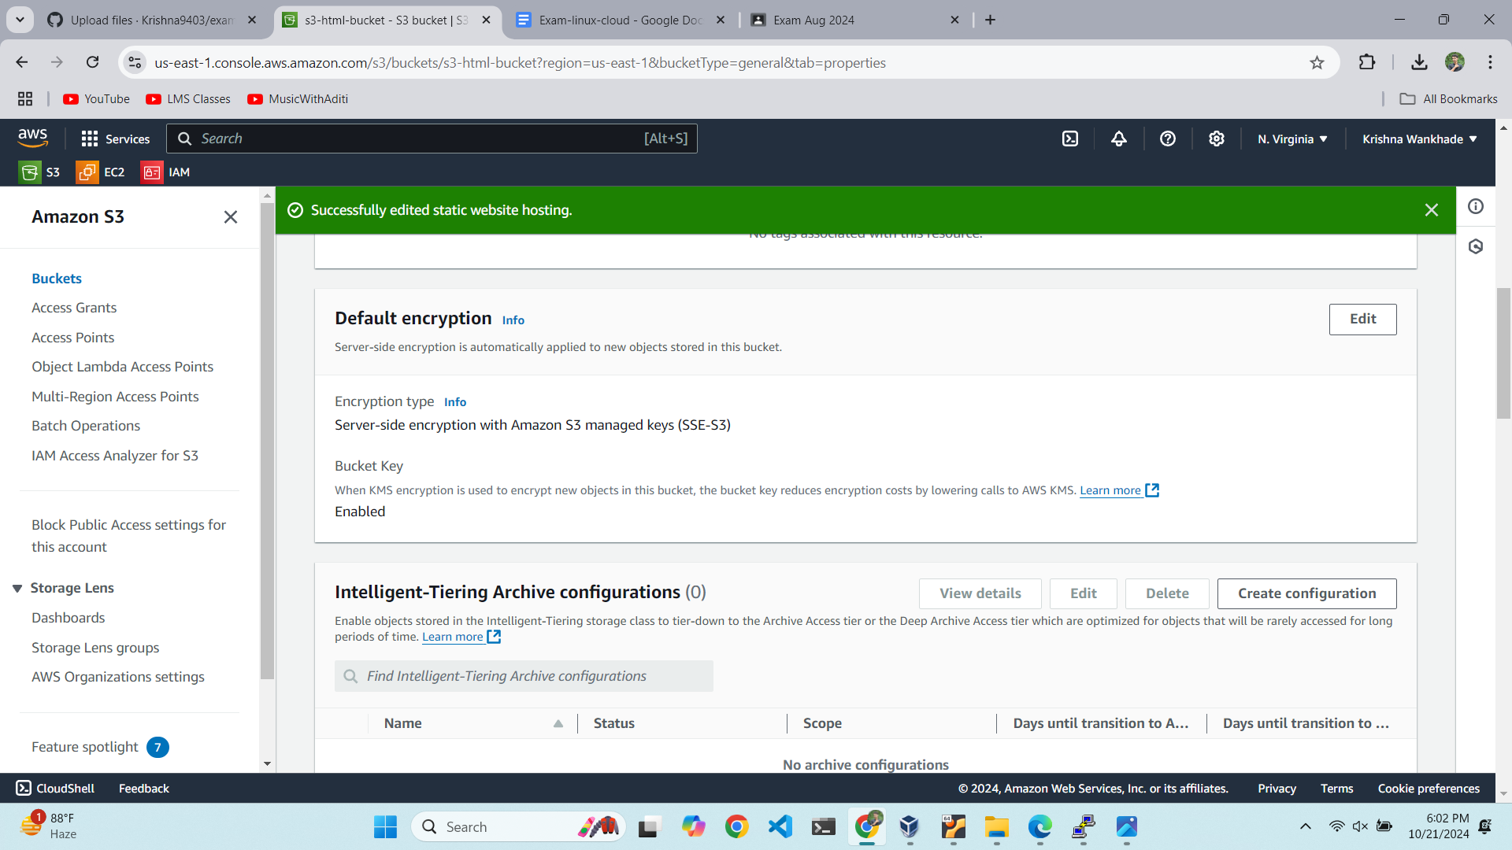

Accessing URL

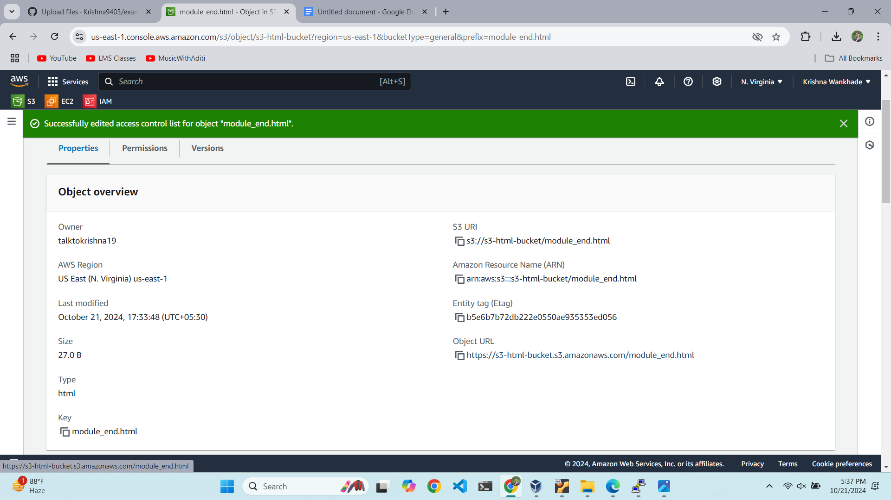

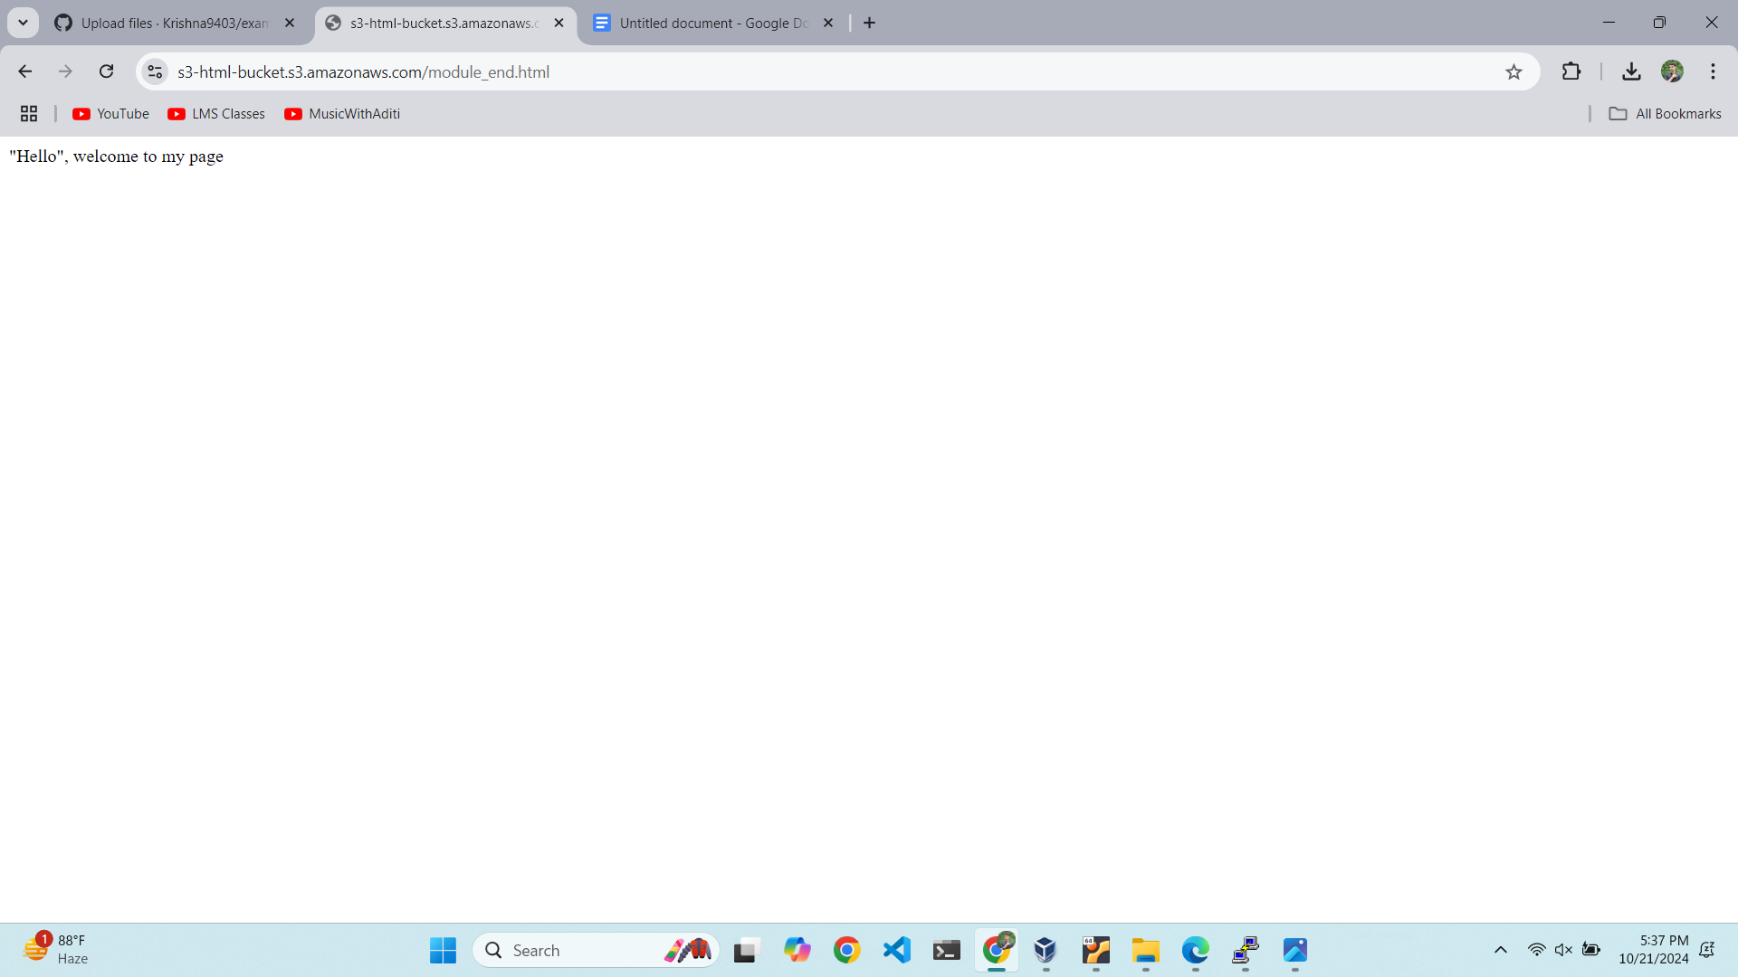

https://s3-html-bucket.s3.amazonaws.com/module_end.html